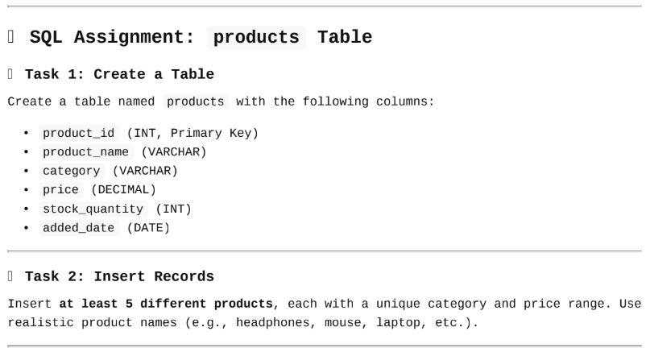

-- Task 1: Create a Table

create table products(

products_id int primary key,

product_name varchar(50),

category varchar(50),

price decimal(10,2),

stock_quantity int,

added_Date date

);

-- Task 2: Insert Records

insert into products(products_id, product_name, category, price, stock_quantity, added_Date)

values

(1,'Headphones','Electronics',300.00,80,'2023-01-01'),

(2,'Mouse','Electronics',500.50,15,'2023-02-01'),

(3,'Laptop','Electronics',45500.00,8,'2023-03-01'),

(4,'Sofas','Furniture',85599.00,52,'2023-04-01'),

(5,'Chairs','Furniture',599.50,66,'2023-05-01');

-- Task 3: Write Queries

-- 1. List all products.

select * from products;

-- 2. Display only product_name and price.

select product_name,price from products;

-- 3. Find products with stock_quantity less than 10.

select * from products where stock_quantity < 10;

-- 4. Find products with price between 500 and 2000.

select * from products where price between 500 and 2000;

-- 5. Show products added after 2023-01-01 .

select * from products where added_Date > '2023-01-01';

-- 6. List all products whose names start with ‘S’.

select * from products where product_name like 'S%';

-- 7. Show all products that belong to either Electronics or Furniture.

select * from products where category in ('Electronics','Furniture');

-- Task 4: Update & Delete

-- 1. Update the price of one product.

update products

set price = 399.50 where products_id=1;

-- 2. Increase stock of all products in a specific category by 5.

update products

set stock_quantity=stock_quantity+5 where category='Electronics';

-- 3. Delete one product based on its product_id .

delete from products where products_id=5;

-- 4. Delete all products with stock_quantity = 0.

delete from products where stock_quantity=0;

select * from products;